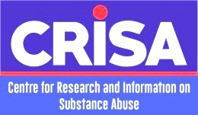
13th Biennial International Conference
Drugs, Alcohol and Society in Africa
19 – 20 September, 2018
Riez Continental Hotel, Abuja

Conference Registration Form

- Last Name: ______________________ First Name: _____________________ Title___________________________________________
- Affiliation:___________________________________________________________________
- Phone: ______________________________ Fax: __________________________________
- E-mail Address: ______________________________________________________________
- If you have submitted a paper, please supply the title below:
___________________________________________________________________________
- Registration (Tick where appropriate)
Amount: _________________________
- Form of payment: ________ Bank transfer ________ On-site ____________ Cheque
CRISA Account Information
Account Name: CRISA
Bank: G T Bank
Account Number: 0042755970 Routing Numbing: 058015513

